HAIR & BEAUTY PARLOUR LISTING WEBSITE DOCUMENTATION

1. WEBSITE SPECIFICATIONS

a. Website Objective

The main objective of the website is to develop a centralized online platform that allows users to easily discover, compare, and connect with hair and beauty parlours. The system is designed to improve accessibility to beauty services while also providing a digital presence for local businesses.

b. Website Goals (SMART Goals)

- Specific: To provide a directory with at least 100 registered beauty parlours.
- Measurable: To reach 1,000 monthly users within the first 3 months after launch.
- Achievable: By allowing free business listings to attract salon owners.
- Relevant: To support both customers looking for services and businesses seeking exposure.
- Time-bound: To design, develop, and launch the website within 12 weeks.

c. Target Audience

Primary Audience:
-General public
- Individuals interested in personal grooming and beauty services
- Tourists visiting the country who need access to nearby beauty services.

Secondary Audience:

- Salon owners, hairstylists, nail technicians, and makeup artists

Demographics:

- Gender: All genders
- Location: Everywhere in Botswana
- Income Level: Low to middle income
- Occupation: Students, entry-level workers, small business owners

Technical Aptitude:

- Familiar with smartphones and mobile apps
- Regular users of the internet and social media
- Comfortable browsing websites and using search features

d. Type of Website

- Directory / Listing Website
- Informational and Interactive Platform

2. INFORMATION DESIGN & TAXONOMY

a. Information Architecture

The website content will be structured into clear and user-friendly categories to enhance usability.

Main Categories:

- Hair Salons
- Nail Salons
- Makeup Artists
- Manicure Services
- Pedicure Services

Secondary Categories:

- Location (e.g., Gaborone, Francistown)
- Price Range
- Ratings and Reviews

b. Site Map Structure
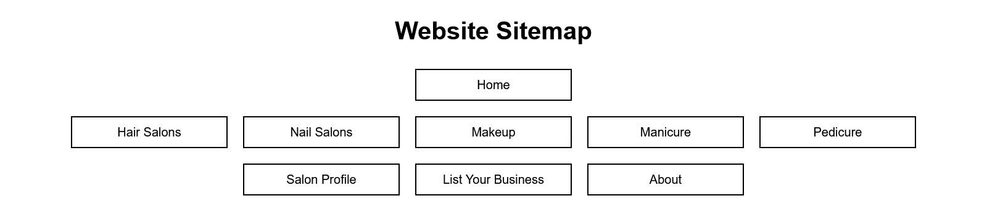

Home Page

- Navigation Bar
- Hair Salons
- Nail Salons
- Makeup
- Manicure
- Pedicure
- Search Bar
- Featured Listings
- “List Your Business” Button

Category Pages

- Filters (location, price, ratings)
- List of businesses

Salon Profile Page

- Business Name
- Images
- Services Offered
- Pricing
- Reviews

List Your Business Page

- Registration Form
- Business Details Submission

About Page

- Website Information
- Contact Details

c. Navigation Flow (Storyboard Explanation)

1. User visits the Home Page
2. User searches or selects a category
3. User browses available salons
4. User selects a specific salon
5. User views detailed information
6. User decides to contact or visit the salon

3. PAGE TEMPLATE DESIGN
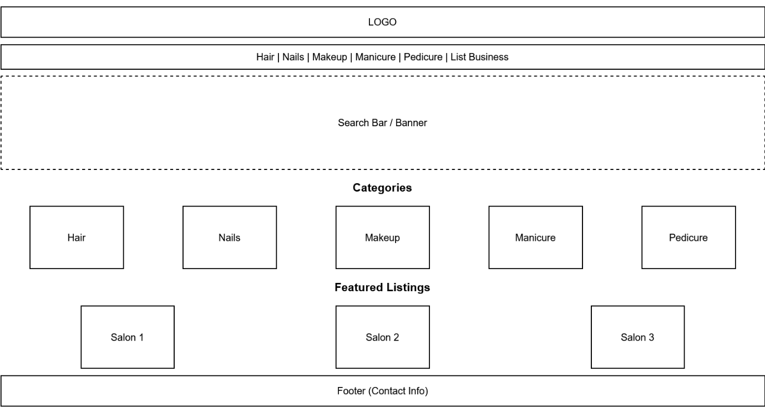
DESCRIPTION

Home Page Layout

- Header

- Logo (top left)
- Navigation menu (centre)
- “List Your Business” button (top right)

- Hero Section

- Banner image
- Search bar

- Categories Section

- Icons for different services

- Featured Listings

- Salon cards with images and ratings

- Footer

- Contact information
- Social media links

Salon Listing Page Layout

- Sidebar filters (location, price, rating)
- Grid display of salon listings

Salon Profile Page Layout

- Salon name and image gallery
- List of services and pricing
- Customer reviews
- Contact option

4. TECHNICAL BRIEF

a. Technologies to used

- Frontend:

- HTML5
- CSS3
- JavaScript

- Database:

- MySQL

b. Tools & Software

- Visual Studio Code
- GitHub
- Draw.io
- Figma

c. Hosting & Deployment

- Web hosting service
- Domain name registration

d. Compatibility Requirements

- Responsive design for mobile and desktop
- Compatible with major browsers:
- Google Chrome
- Mozilla Firefox
- Microsoft Edge

5. QUALITY ASSURANCE (TESTING)

a. Functional Testing

- Verify that search functionality works correctly
- Ensure all navigation links function properly
- Test form submissions

b. Usability Testing

- Evaluate ease of navigation
- Ensure the interface is user-friendly

c. Compatibility Testing

- Test across different browsers
- Test on mobile and desktop devices

d. Performance Testing

- Check loading speed
- Optimize images and scripts

e. Test Evidence

Include screenshots showing:

- Website on mobile device
- Website on desktop
- Working search results
- Navigation between pages

Conclusion

This website is designed to improve access to beauty services while supporting local businesses by providing them with an online platform. The system focuses on usability, accessibility, and efficiency to ensure a positive user experience.

